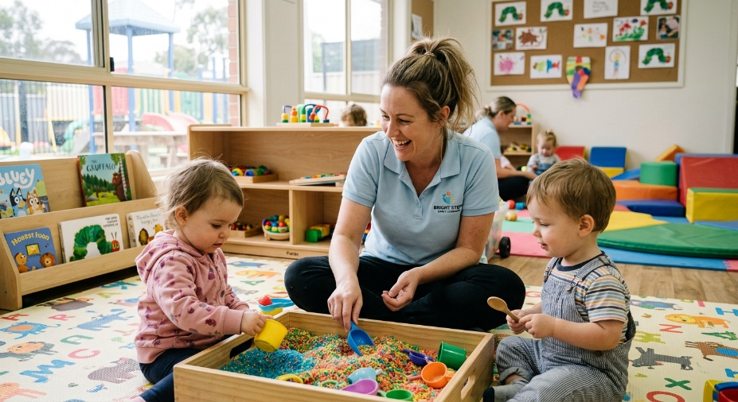
Learner #8: Sarah Jenkins

About Me: | Sarah is a 36-year-old Educator Assistant at Little Stars Early Learning, based in South Australia, where she returned to part-time work in early 2025 after a five-year career break to raise her two young children (now aged 4 and 6). She lives in the southern suburbs with her wife and the kids, and her current shift pattern is school hours only, four days a week.
Professional and Learning Experience: | Sarah holds a Certificate III in Children's Services (2010), a legacy qualification with units that have been superseded and will require verification against the current CHC Community Services Training Package. She has prior experience as an Assistant Educator across various centres between 2011 and 2018, and has been back in the toddler room at Little Stars under lead-educator supervision since early 2025. Her current first aid is due for renewal, and her knowledge of the National Quality Framework and EYLF v2.0 is acknowledged in her recent appraisal as needing a refresh.  Sarah has done a small amount of informal training on the floor, including showing a new colleague (Amy) how to use the nappy change log, and she recently put together a sensory bin project using recycled materials for the toddler room. She is enrolled in TAE40122 as part of a longer-term plan to move into a more senior educator role and eventually into trainer work within early childhood.
Career/Training Goals: | Sarah's immediate goal is to rebuild her sector currency, complete an NQF refresher, and progress toward a Diploma of Early Childhood Education and Care alongside the Cert IV in TAE. Longer term, she would like to deliver short courses or workshops for parents and new educators, drawing on her own experience returning to work after a long break. She is open to extending into broader CHC delivery if her early childhood pathway opens up over the next few years.
Working Style and Preferences: | Sarah is warm, patient, and very natural with the children, which is the strongest theme in both her centre director's reference and her appraisal. She is genuinely good at the relational and supervisory side of the role and has mentioned that she finds the rhythm of the toddler room very settling after the chaos of running her own household. The areas where Sarah's confidence is lower are documentation, formal observation write-ups, and anything involving structured planning around dates, sequences, or rosters. Her informal training note about the new starter Amy was missing the date, the full learner’s name, and any supervisor signature, and her recent staff-room cleaning roster meeting required her manager to step in to convert her hand-written notes into the published version.  Sarah has shared that numbers and dates have always been a struggle for her: she has trouble with mental arithmetic, mixes up similar numbers (such as room codes, phone extensions, and dose quantities) under pressure, and double-checks every roster, calendar, and spreadsheet at least twice before she trusts it. She uses her phone calendar heavily as a memory aid and has set up colour-coded reminders for everything from medication times for her own children to centre rostering. Her writing is otherwise clear and her reading is strong; the issue is specifically with numerical and sequence-based information.  Sarah is comfortable enough with email, the centre's parent communication app, and Word, and her family has a shared laptop and reliable home internet, although she usually studies after the children are in bed.
Additional Information: | Sarah is a part-time canteen volunteer at her older child's primary school and runs the local mums' walking group on Saturday mornings. Her preferred way of learning new content is in small, hands-on group settings with plenty of demonstration; she finds online self-paced modules harder to stay engaged with and would benefit from a structured weekly check-in. She has mentioned that returning to formal study after seven years feels intimidating, and that having a clear written roadmap for what is due and when would help her enormously.

